Platform as a Service (PaaS)
# Source: Chatgpt (GPT-5-Mini) at [1/16/2026]
PaaS is a cloud computing service model that provides a platform for developers to build, deploy, and manage applications over the Internet without worrying about the underlying infrastructure.
It sits between IaaS and SaaS, giving developers tools to focus on coding and deployment instead of hardware and OS management.

Definition
# Source: Chatgpt (GPT-5-Mini) at [1/16/2026]
PaaS:
- Provides hardware and software tools hosted by a cloud provider
- Users focus on application development
- Provider manages servers, storage, networking, OS, and middleware

Architecture Diagram
# Source: Chatgpt (GPT-5-Mini) at [1/16/2026]
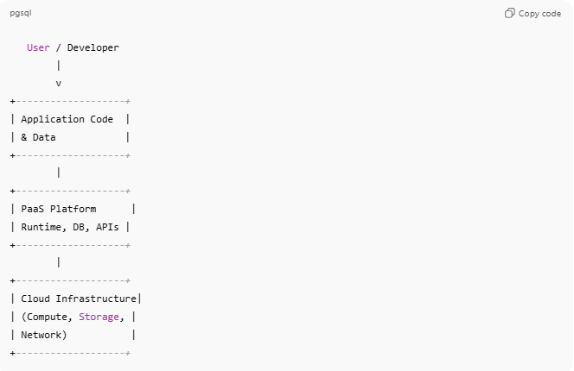
User / Developer
|
v
+-------------------+
| Application Code |
| & Data |
+-------------------+
|
+-------------------+
| PaaS Platform |
| Runtime, DB, APIs |
+-------------------+
|
+-------------------+
| Cloud Infrastructure|
| (Compute, Storage, |
| Network) |
+-------------------+
- User responsibility: Application code and data
- Provider responsibility: OS, runtime, middleware, infrastructure

Key Features
# Source: Chatgpt (GPT-5-Mini) at [1/16/2026]
- Provides development tools, runtime environments, and databases
- Handles scaling, load balancing, and updates automatically
- Supports multiple programming languages and frameworks
- Allows rapid development and deployment

Examples
# Source: Chatgpt (GPT-5-Mini) at [1/16/2026]
- Google App Engine – Deploy apps without managing servers
- Microsoft Azure App Service – Web and mobile app development
- Heroku – Cloud platform for deploying applications quickly
- Red Hat OpenShift – PaaS for enterprise apps

Advantages
# Source: Chatgpt (GPT-5-Mini) at [1/16/2026]
- Developers focus on application logic, not infrastructure
- Faster time-to-market for applications
- Automatic scaling and maintenance
- Cost-effective: pay for the platform and resources used

Disadvantages
# Source: Chatgpt (GPT-5-Mini) at [1/16/2026]
- Limited control over underlying infrastructure
- Vendor lock-in for platform-specific tools or frameworks
- Less flexibility compared to IaaS for custom configurations

Simple Analogy
# Source: Chatgpt (GPT-5-Mini) at [1/16/2026]
- PaaS: Renting a fully furnished and equipped office
  - You bring your work (application code)
  - Office provider handles furniture, electricity, internet, and maintenance (OS, runtime, database, infrastructure)

